Hardware instructions (Senior design)
- You have to install Ubuntu onto the Raspberry Pi.
- Then go to this website and follow the instructions to download the linux utility for the Orion BMS onto the Pi. https://www.orionbms.com/manuals/utility/installation_linux.html (Shows how)
- https://www.orionbms.com/products/orion-bms-standard#downloads (go to orion bms 2 software utility and download where it says linux)
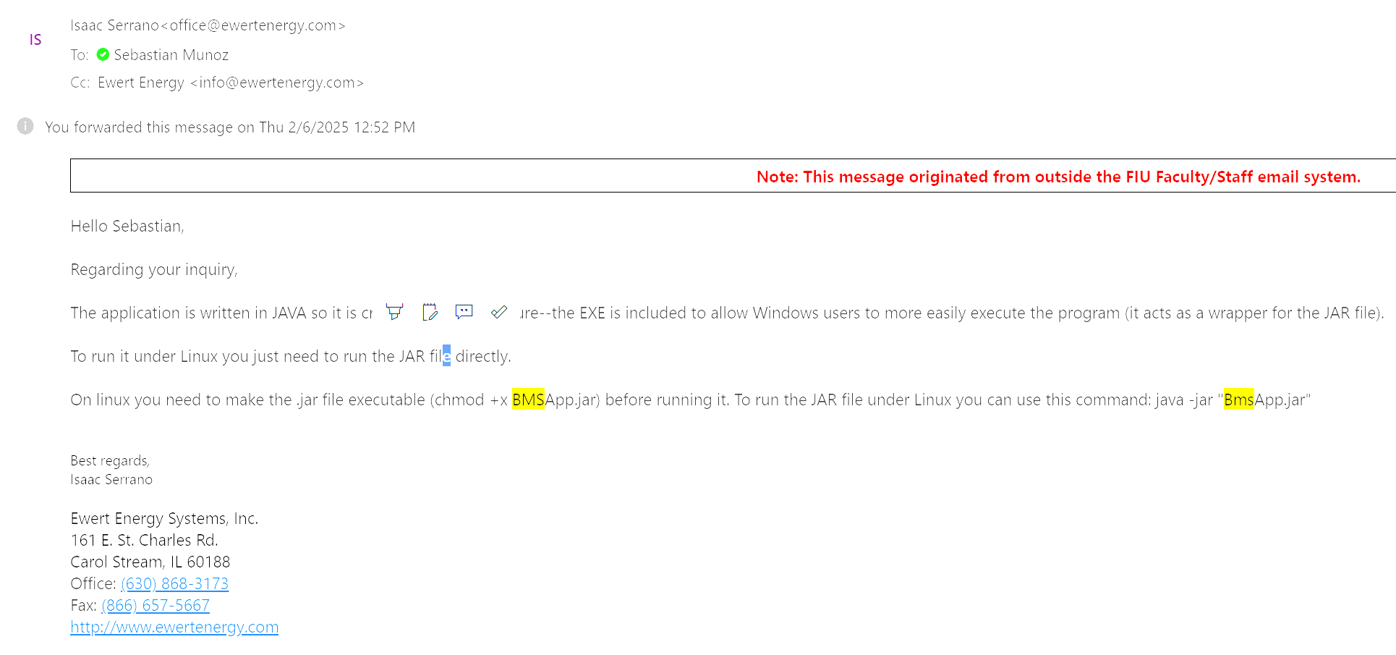
This was an email I got from the customer support in order to be able to run the utility.
We were able to use the code “
java -jar /home/jacob/Downloads/orionbms2_utility_stable/orionutility/BMSApp.jar “
To pull up the utility using the terminal window(replace the path you use as needed
- Make sure the candapter is connected via usb by using
“sudo dmesg | grep tty”
- You should see something along the lines of FTDI USB SERIAL DEVICE CONVERTER NOW ATTACHED TO USB0
- Install all can utilities
sudo apt update
sudo apt install can-utils
- Enable the kernel can modules
sudo modprobe can
sudo modprobe can_raw
sudo modprobe slcan
- Then you have to configure the usb port to be the can port. For example we had it at “USB0” linked to the canport in order to link it with the can-bus that is coming off the Orion BMS. *Note we tried on both the Pi 4b and the Pi 5 and for some reason we were not able to get it to work on the 4b.
We used this code to link TTYUSB0 to CAN0
“sudo slcand -o -c -s8 /dev/ttyUSB0 can0
sudo ip link set can0 up”
Once that is set you can then open the utility and click connect to BMS.
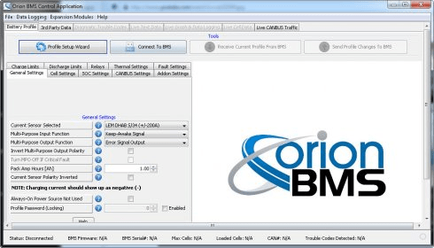

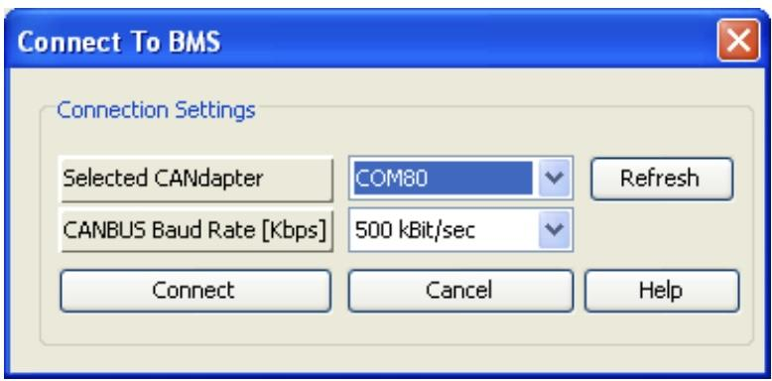

The canbus baud rate should be at 1MBIT/SEC and the selected CANdapter should automatically get put in if you did everything correctly.
- Once connected If you do not have a profile to download then you will need to create one using the profile setup wizard which is to the left of connect to BMS.
- You can select the paths from 1-72 with each path wired directly to each individual cell. Choose the path you are using in the profile setup wizard and then load the profile. We are using the 5th set off paths due to the first and second paths 1-24 having blown fuse and blown diodes. So we are currently using paths 49-60.
- Once your profile is set up you can then check for faults, look at live cell data, and even record data using the live graphing feature.

- Wiring diagram
- The photo below is the bare bones of where the current is going. We have the battery pack which has all the sensors attached to it going straight to the bms. We have the BMS directly attached to the orion bms using the candapter. Then we have the most positive lead coming out from the bms going to both relays. The other side of each early will go to the load (the two resistors we have in series to equal 20 ohms to simulate driving the car and the chargers positive lead.
- The most negative side of the battery pack will come out and connect to both the chargers negative lead and the end of the two resistors completing both circuits.
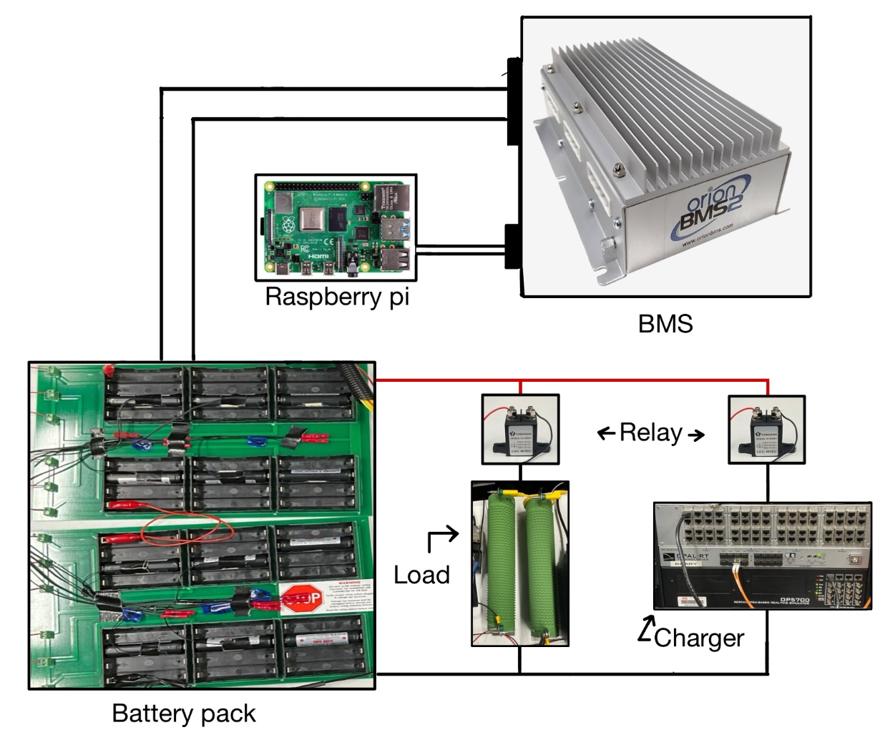

- With the main system hooked up now you need to power the relays and the BMS itself. Below is the final setup we had when we were testing showing how everything is hooked up.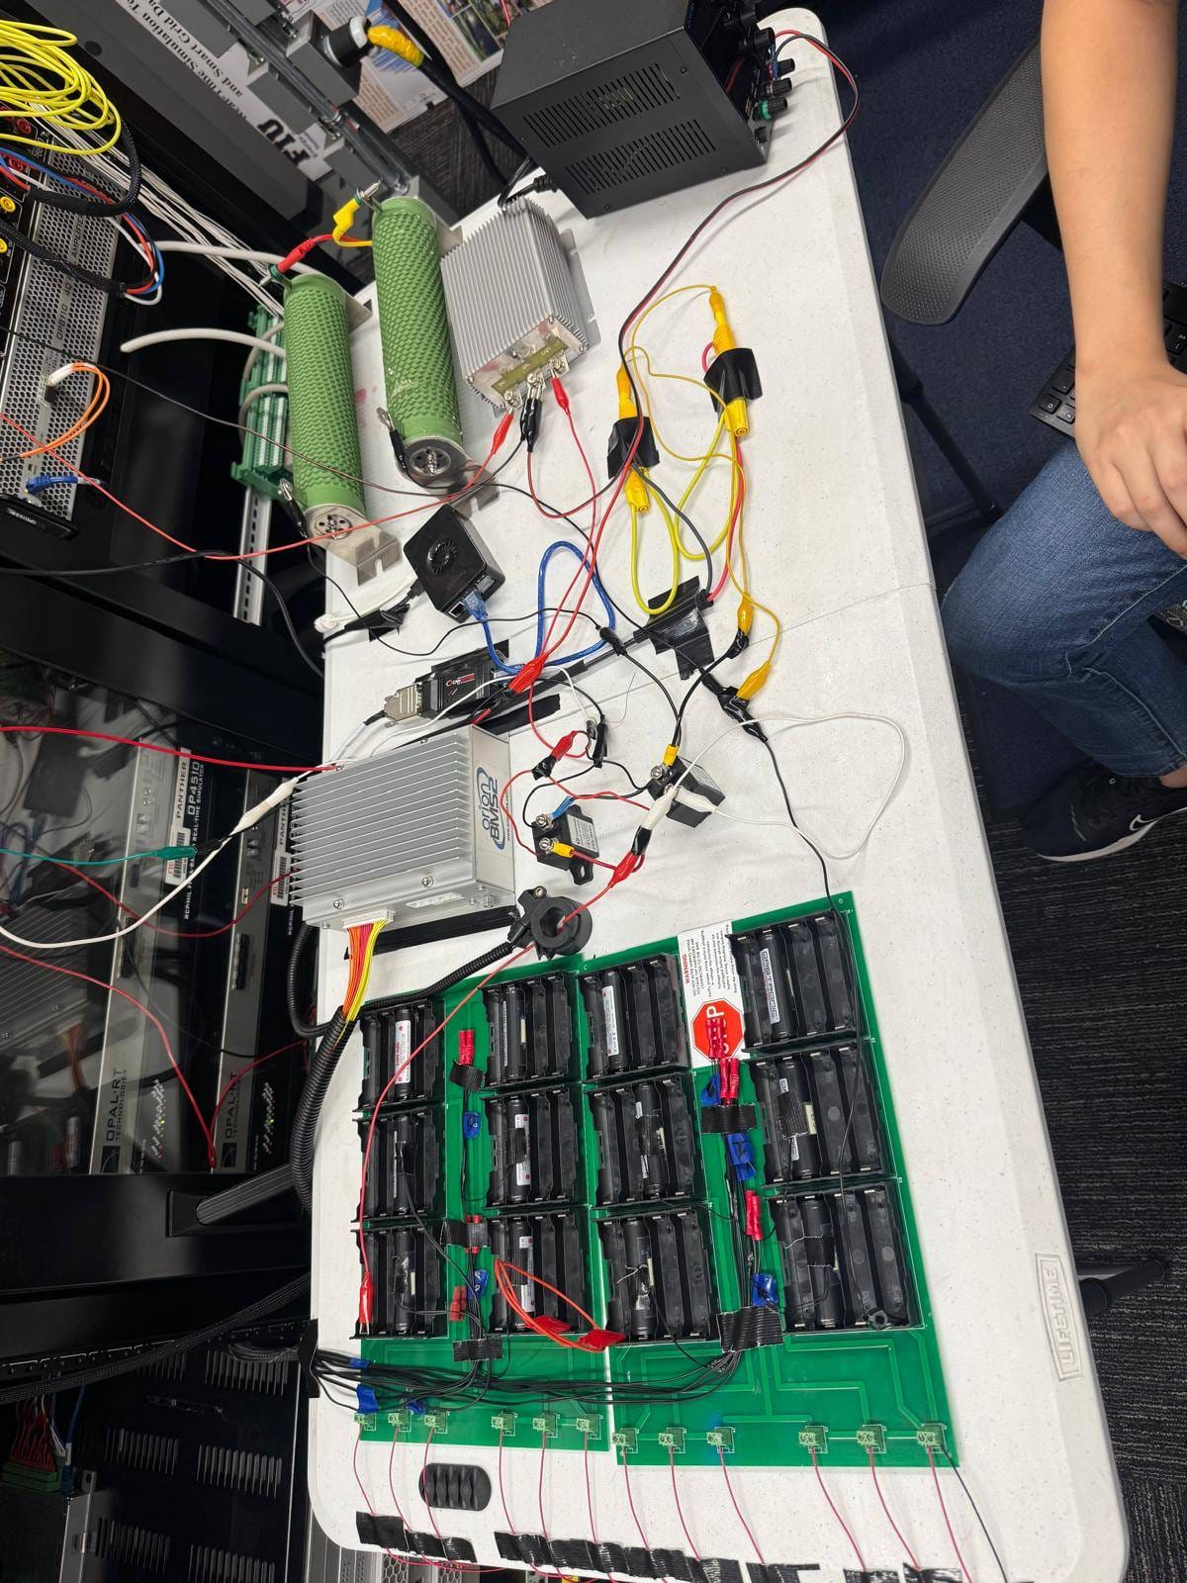
- First the relays. You should notice a red and black control wire coming out of them. The red is going to be supplied power so we need to give them each 48 volts. We do not have 48 volts. What we do have is two 30 volt power supplies. Channel one we will leave for the BMS so on channel two we are going to select 12V. We are going to connect that 12V to the 12/48V DC/DC step up to give us the voltage we need then connect the output to the red control on both relays. Remember everything in the circuit needs to share a ground!!! For the black control on the relays you will need to identify the wiring on the bus bar.

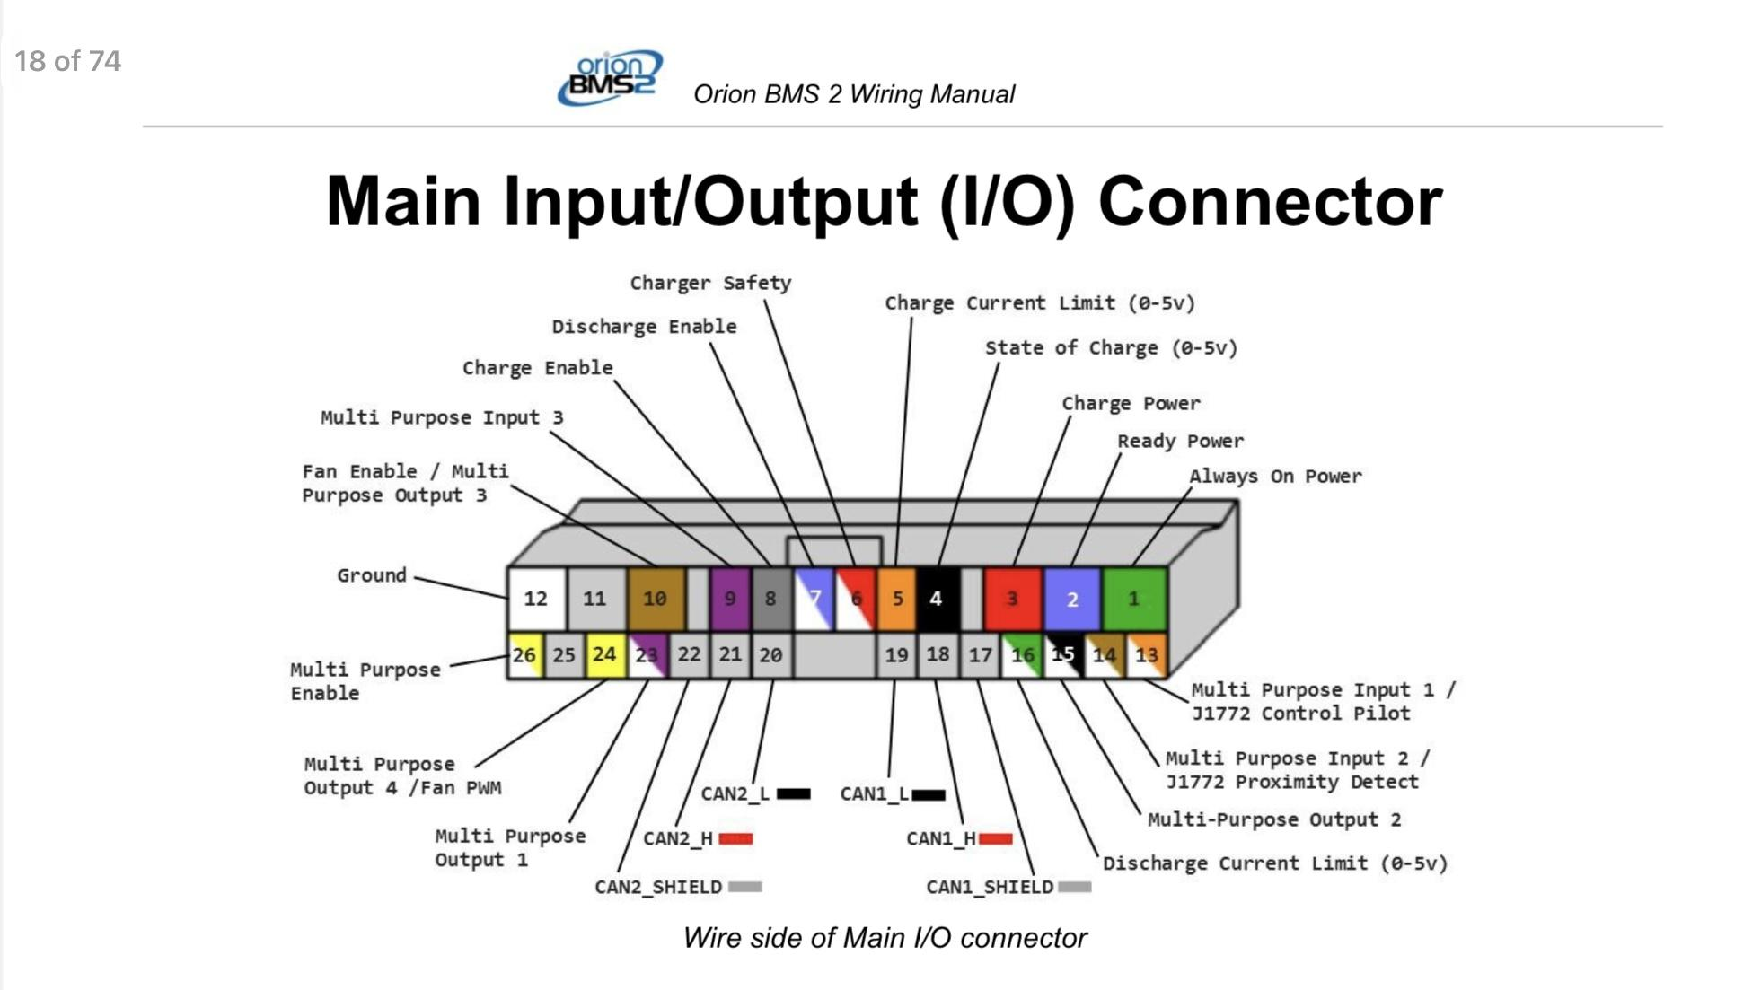

- For the relays you will need to focus on using discharge enable (dont look at number look at color of wire) and charger safety. It is very simple whatever wire you have in discharge is going to go to the relay connecting the load and whatever wire you have in charger safety will go to the relay connecting the charger. These grounds will only open when the BMS tells them to so the circuit will remain open unless directed to otherwise. \
- For the BMS you will need to use the first channel on the power supply to give 24V to pin 1 and pin 2 (look at colors only) while ignoring pin 3 for now. The ground for channel 1 and channel 2 should be the same ground!! And that ground should also go to pin 12 so everything has the same ground!
- Now your relays have power and your bms has power. You will then have to switch over the the BMS utility and make sure discharge enable and charger safety are both enabled.
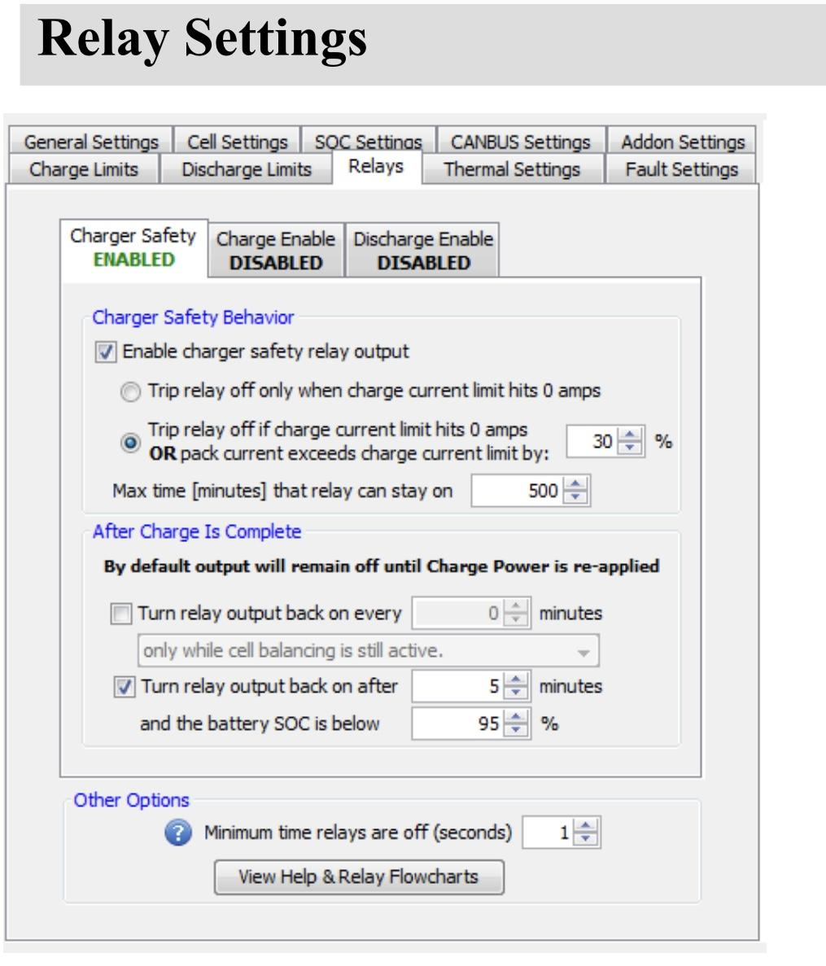

- Once both are enabled you will be able to go to charge limits and discharge limits to change the parameters for charge and discharge.
- Now for pin 3 which is for charging. With the setup you currently have, only the discharge relay will turn on even when you start to charge. To get the discharge enable relay to shut off you need to supply voltage from 12v to pin 3 or charge power. We tried connecting the charger to it but never got it to work due to the relays being too close and the high voltage causing relays to shut off and on repeatedly. As soon as pin 3 senses voltage it should shut off the discharge enable relay and turn on the charger safety relay and when the voltage is gone it will switch back to discharge as long as the batteries have enough juice.
- Below is a wire by wire diagram of every single connection we did.

